Detection of AI Generated Deepfakes using CNN and LSTM

Kamakshi

UG Scholar

Department of Electronic and Communication

Engineering

KCG College of Technology

Karapakkam, Chennai, Tamil Nadu

22ec34@gamil.com

J Claret De Cruz

UG Scholar

Department of Electronic and Communication

Engineering

KCG College of Technology

Karapakkam, Chennai, Tamil Nadu

jclaretdecruz@gamil.com

Dr. T. Thomas Leonid

Assistant Professor

Department of Electronic and Communication

Engineering

KCG College of Technology

Karapakkam, Chennai, Tamil Nadu

thomasleonid@kcgcollege.com

Alan Moses V P

UG Scholar

Department of Electronic and Communication

Engineering

KCG College of Technology

Karapakkam, Chennai, Tamil Nadu

22ec06@gamil.com

Abstract -- The rapid rise of deepfakes has become a significant threat to the authenticity of digital content, making reliable detection more important than ever. This paper introduces a hybrid, multi-modal deepfake detection framework that integrates an ensemble of four CNN architectures namely DenseNet201, EfficientNetB5, Xception, ConvNeXtSmall for feature extraction. These features are fused and classified using an XGBoost to leverage the strengths of distinct architectural designs. To ensure interpretability, the system also incorporates a Grad-CAM module, showing pixel-level heatmaps that visualize the specific facial regions contributing to the model's decision.
Index Terms-
I. Introduction
The recent accelerated development of generative Artificial Intelligence (AI) and in particular models such as Generative Adversarial Networks (GANs) and advanced autoencoders has led us to the era of hyper-realistic synthetic media [2], [10]. Such technologies have the capability to create deepfake videos and audio that is so believable and appears convincing as authentic data of real people their voices, faces, and expression-that it is nearly impossible to differentiate between them and authentic content. Although these inventions are creative and have useful purposes in other fields such as film, virtual reality and assistive technology, there has been serious concern in their misuse as a society issue. Deepfakes are becoming more widely applied to disseminate fake news, commit identity fraud, slander people, and undermine the trust of the population in online communication [7].
With the advanced forms of generative models, even the tiny flaws that used to expose a work of forgery, distorted images, or uncanny robot-like speech are fast fading away. The vast majority of current methods of detection concentrate on a single type of data-visual artifacts or time inconsistency in a video sequence [8]. Although these techniques work in certain situations, their obvious weakness lies in the fact that a forger can master one of these modalities and circumvent the detector. As an example, a video can appear aesthetically perfect but still have minor glitches in its audio channel, but a detector that looks at the video only will not notice them at all [5]. This brings out the significance of multi-modal detection systems which examine various types of evidence in combination.
II. Background Study
As the growth in generative AI keeps on increasing and becomes more and more accessible for everyone, and require less effort to make them and with how much social media exposure everyone has, it has become a concerning factor, just from the year 2023 to 2025 the spike is huge from over 500k videos to over 8M videos online, Voice attacks are the top as they are very easy to make and efficient.
With huge advancements in AI, especially generative AI and face swapping and voice cloning technology emerging, the growth in AI generated Deepfakes keep on increasing.

III. System Design
The proposed system utilizes ensemble architecture instead of the just using a single model, the system for Image and Video uses 4 different models which are ConvNeXtSmall, DenseNet201, EfficientNetB5 and Xception. The 4 different CNN models are used as feature extractors for the input image, each model sees the image differently because of its own unique architecture. Then we use the XGBoost machine learning algorithm to gather all the information from the 4 CNN models and make the final prediction as real of fake, this applies for Images and for videos all the frames are extracted from the input video and are sent to the same 4 CNN models to get the prediction and once all the frames are analyzed the output is show and based on the average the result is shown as real or fake. The audio system uses a different approach it uses a hybrid architecture with the use of a Mel-Spectrograph to predict if the audio is fake or real.
IV. Methodology
The models are all deep learning networks designed for image recognition, in this project they are used to convert a raw image (pixels) into a list of meaningful numbers (features) that represent textures, edges, and potential AI generated artifacts.
DenseNet201
The DenseNet201 is a Densely Connected network where every layer receives inputs from all previous layer, this models is excellent in preserving information, In AI generated Deepfakes, artifacts might be subtle and lost in deep networks, and DenseNet201 ensures that these details are passed till the end. It concatenates feature map from the previous layers to form a “collective knowledge” as the output.
EfficientNetB5
This model is optimized for efficiency and accuracy by carefully balancing network depth, width and image resolution, the EfficientNetB5 model is very good at capturing complex, high-level patterns without being excessively heavy. It detects the global consistency of the face, it also uses compound scaling to look at features at multiple scales simultaneously.

Xception
This model relies on Depth wise Separable Convolutions, Xception is often cited as the top performer in deefake detection as it is highly sensitive to image compression artifacts and noise patterns, which are common in GAN-generated faces, It process spatial patterns (width/height) and cross-channel patterns(colors) separately, making it more efficient and often more accurate for texture analysis
ConvNeXtSmall
This model was developed to compete with the Vision Transformers (ViT), the model acts as an eye it uses larger kernel sizes to see wider context of the face at once, helping to spot artifacts in the image which older models might miss like mismatch between eyes and mouth. The model follows the structure of transformers but uses standard convolution operations.
XGBoost
Known as Extreme Gradient Boosting, this model acts like a brain in this project instead of letting the CNNs vote, the XGBoost learns which CNN is right in which situation, for example if DenseNet says the image is “fake” and Xception says the image is “real”, XGBoost decides which one to trust based on its training. The XGBoost builds hundreds of small decision trees, and each tree tries to correct the errors of the previous tree, it takes the massive list of features from the CNNs and find the mathematical boundary between “real” and “fake”

Technology Used
We have trained 4 Models for the Image classification ConvNeXtSmall, DenseNet201, EfficientNetB5 and Xception, we have used the same for video analysis as well for video we extract each and every frame one at a time and run it through the image models and the then merge them all and find the mean and give the output as fake or real

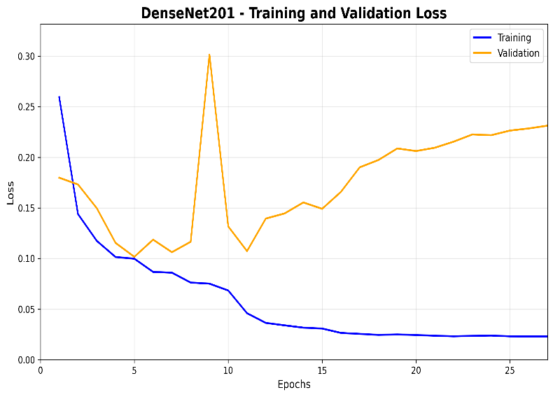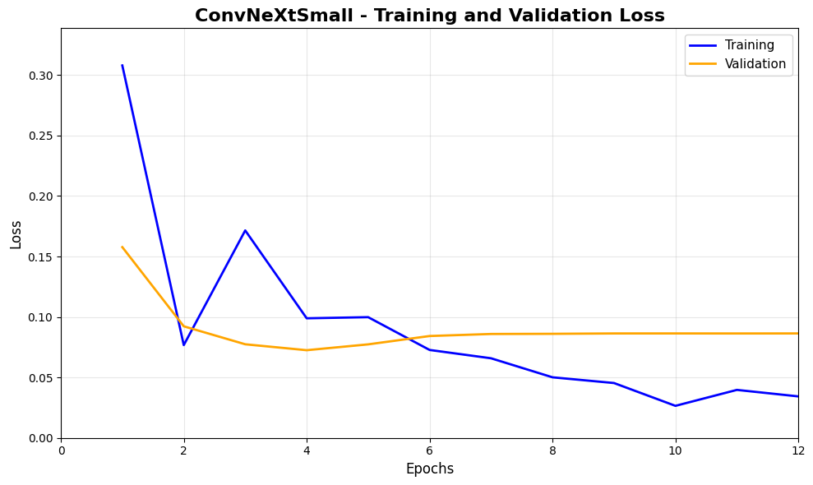
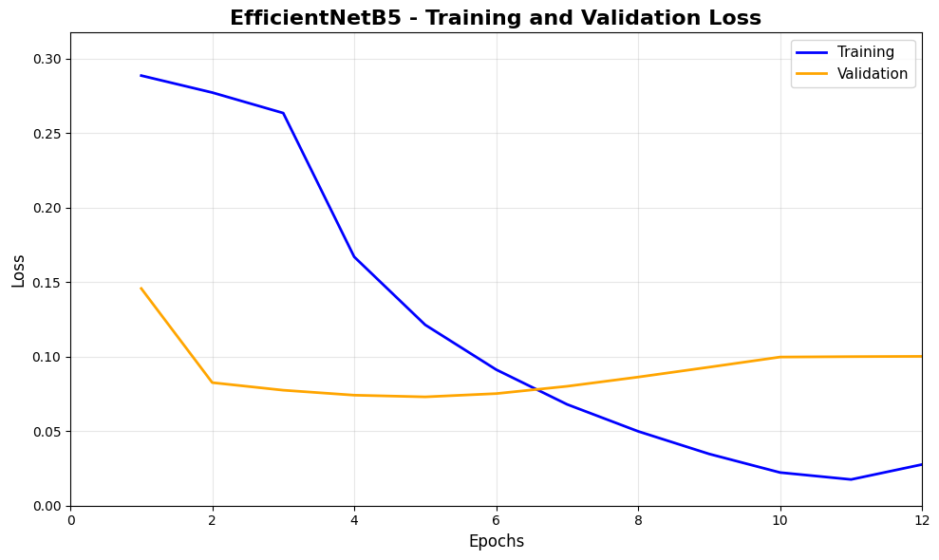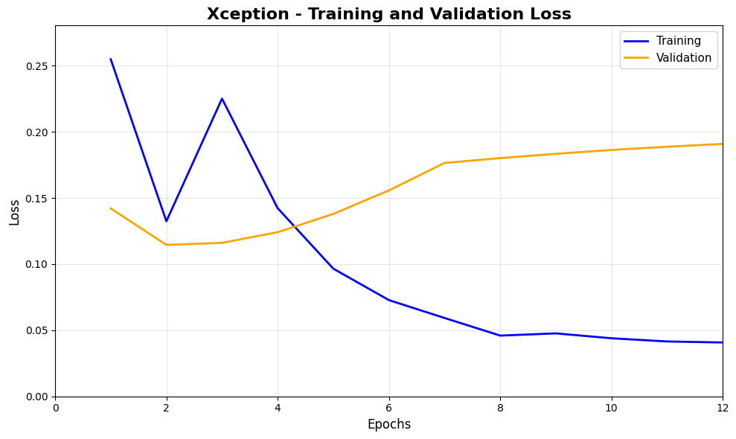

The 4 models were trained on 3 datasets, the datasets used were CelebDF, FaceForensic++, Wild-Deepfake
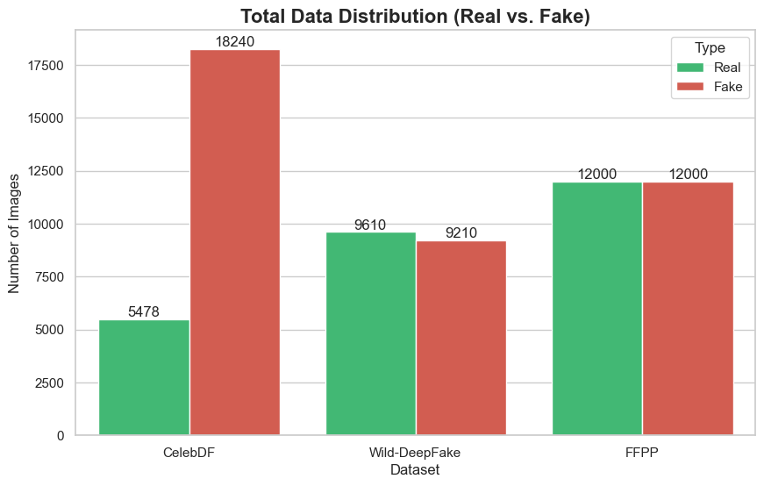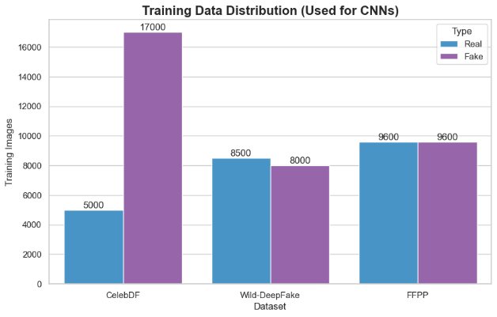
Dataset | Real | Fake
CelebDF (image) | 5478 | 18240
Wild-Deepfake (image) | 9610 | 9210
FFPP (image) | 12000 | 12000
Total | 27088 | 39450
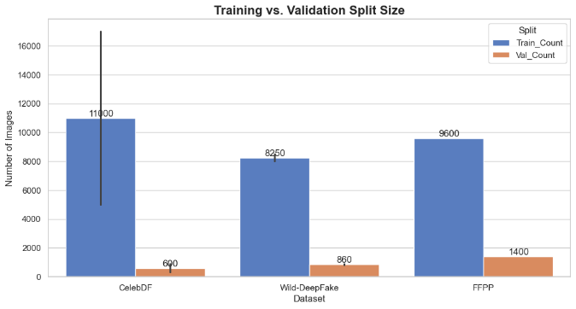

These graphs show us the distribution of the data used from each of the dataset to train the CNN models.

The Confusion matrix
The confusion matrix is a table used to evaluate the performance of an AI classification model, it is used to compare the actual value (the truth) with the predictions made by the AI model, the matrix breaks down correct and incorrect predictions into four categories
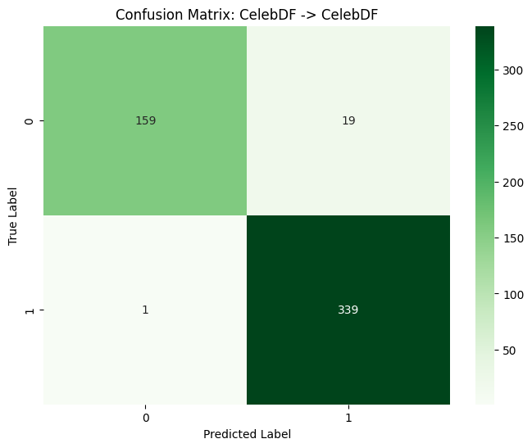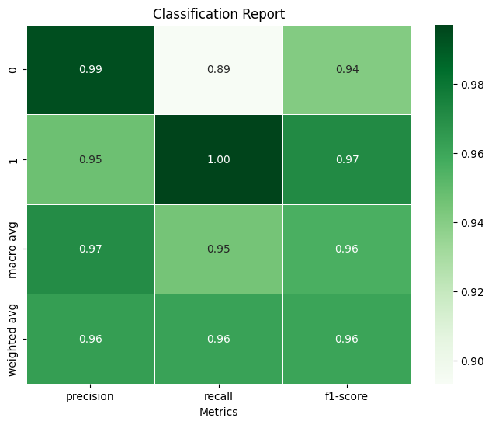

 | Predicted: Fake (Positive) | Predicted: Real (Negative)
Actual: Fake (Positive) | True Positive (TP) | False Negative (FN)
Actual: Real (Negative) | False Positive (FP) | True Negative (TN)

- True Positive (TP):
  - Reality: The image/audio is Fake.
  - Prediction: The model correctly guessed Fake.
  - Outcome: A successful detection of a threat.
- True Negative (TN):
  - Reality: The image/audio is Real.
  - Prediction: The model correctly guessed Real.
  - Outcome: A successful verification of safe content.
- False Positive (FP) – "Type I Error":
  - Reality: The image/audio is Real.
  - Prediction: The model wrongly guessed Fake.
  - Outcome: False Alarm. A legitimate user is flagged as a scammer.
- False Negative (FN) – "Type II Error":
  - Reality: The image/audio is Fake.
  - Prediction: The model wrongly guessed Real.
  - Outcome: Missed Threat. This is the most dangerous error in security because a deepfake slips through undetected.
Accuracy: The total percentage of correct predictions made by the model
Accuracy = (TP+TN)/ (TP+TN+FP+FN)
Precision: This is when the model claims something is fake, how often is it actually fake?
Precision = TP/ (TP+FP)
Recall: Known as the sensitivity, out of all the actual Fakes, how many did the model catch
Recall = TP/ (TP+FN)
F1-Score: The harmonic Mean of Precision and Recall
F1-Score = 2*((Precision x Recall)/ (Precision + Recall))

Audio Model
The Audio Model is trained on the Fake-or-Real audio deepfake dataset, the dataset contains samples of real and fake AI generated voices, and the formats supported are WAV, MP3 and FLAC. The model trained is a CNN-LSTM Hybrid, the CNN is used for extracting frequency features and LSTM is used to learn the temporal Patterns, The input is not the audio wave form rather something called Mel-Spectrogram
Mel-Spectrogram (Input)
Raw audio is just waves of numbers, which is not easy and is hard for AI to analyze and give us a proper result, this method converts the input audio into an image called a Mel-Spectrogram
Mel-Spectrogram is a visual representation of the audio’s frequency (pitch) over time. The “Mel” scale adjusts the frequencies to mimic how the human ear hears sound (sensitive to lower pitches), the reason to use the Mel-Spectrogram is because it reveals subtle “artifacts” or glitches in AI-generated voices that are invisible in the raw waveform but looks like an unnatural blurred spots in the spectrogram. The Input is given in the dimensions
128x94, the 128 is the number of frequency bands (height of the image), 94 is the number of time steps (width of the image) representing a short clip of audio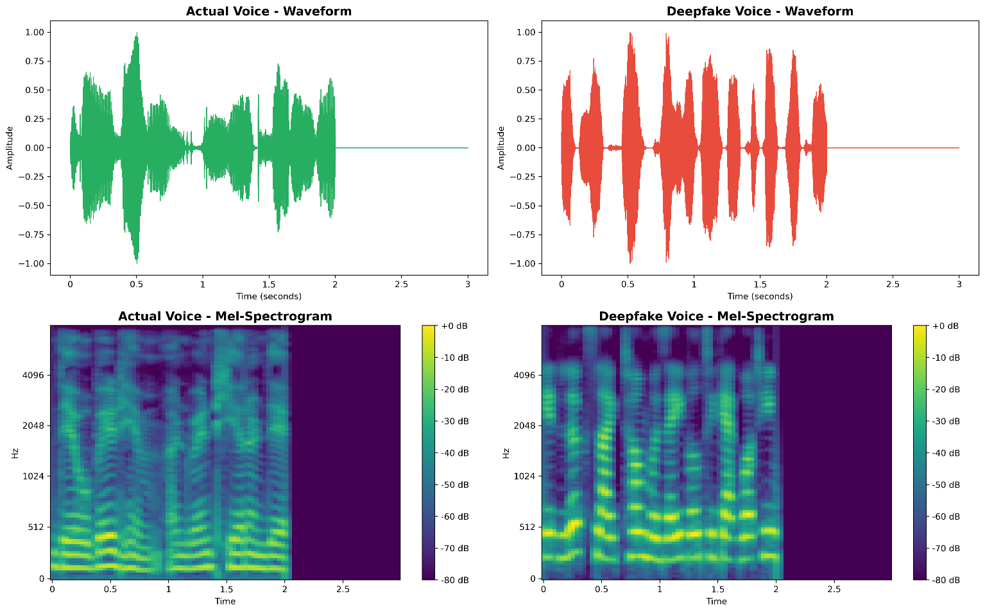
CNN (Convolutional Neural Network)
CNNs are used for image recognition, but here in this project they are used to look at the Mel-Spectrogram.
The role of the CNN is to scan the spectrogram to find spatial patterns, the logic for detection is AI voices often have unnatural pixel patterns in high-frequency areas like metallic sounds or lack of breath noise. The CNN identifies these visual fingerprints of audio deepfake generators. The layers used in training the CNN are Conv2D, MaxPooling2D and Flatten.
Conv2D is the eye of the AI, it passes a small filter (3x3) over the spectrogram to detect patterns, it detects visual artifacts in the audio visualization, such as unnatural “blurring” or specific noise patterns that AI generated deepfakes leave behind, the model have 3 convolutional blocks with increasing filters 32->64->128 allowing it to find simple edges first and complex textures later.
Maxpooling2D is used to shrink the image size, this makes the model more efficient by lowering the calculations the model needs to perform
Flatten is used to convert the 2D/3D map of features into a long 1D list of numbers, this prepares the data for the final decision making layers
Convolutional Blocks (Feature Extraction):
- Block 1:
  - Conv2D: 32 filters, 3x3 kernel, ReLU activation.
  - MaxPooling2D: 2x2 pooling (reduces image size).
  - Dropout: 0.2 (drops 20% of neurons to prevent overfitting).
- Block 2:
  - Conv2D: 64 filters, 3x3 kernel, ReLU activation.
  - MaxPooling2D: 2x2 pooling.
  - Dropout: 0.2.
- Block 3:
  - Conv2D: 128 filters, 3x3 kernel, ReLU activation.
  - MaxPooling2D: 2x2 pooling.
  - Dropout: 0.2.
Classification Head:
- Flatten: Converts the 3D feature maps into a 1D vector.
- Dense Layer: 128 neurons, ReLU activation.
- Dropout: 0.3 (higher dropout for the dense layer).
- Output Layer: 1 neuron with Sigmoid activation (outputs a probability score between 0 and 1 for "Real" or "Fake").

A False Negative of <10% is used, False Negative means when the system says the audio is real when it’s actually fake or AI generated.
Having a False Negative is very important for the security, FN is dangerous because the users can get scammed by AI generated voices, and keeping the rate below 10% the system is able to catch the vast majority of the attacks.

V. Results and Output
As we know AI models are not accurate as they are based purely on prediction, so for detailed analysis we also added the Grad-CAM (Gradient-weighted Class Activation Mapping), this basically shows us which specific pixels in the face convinced the AI that this image is Fake.

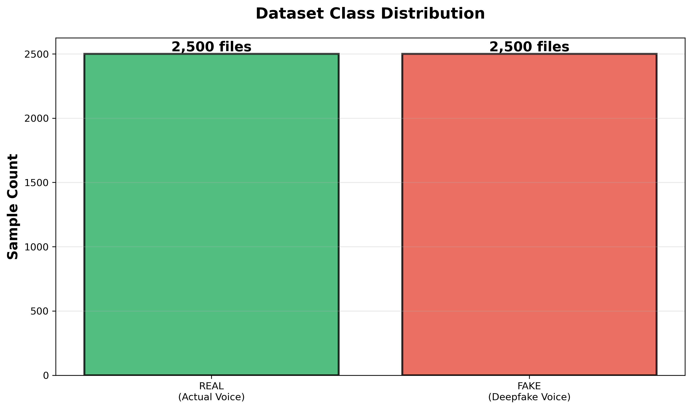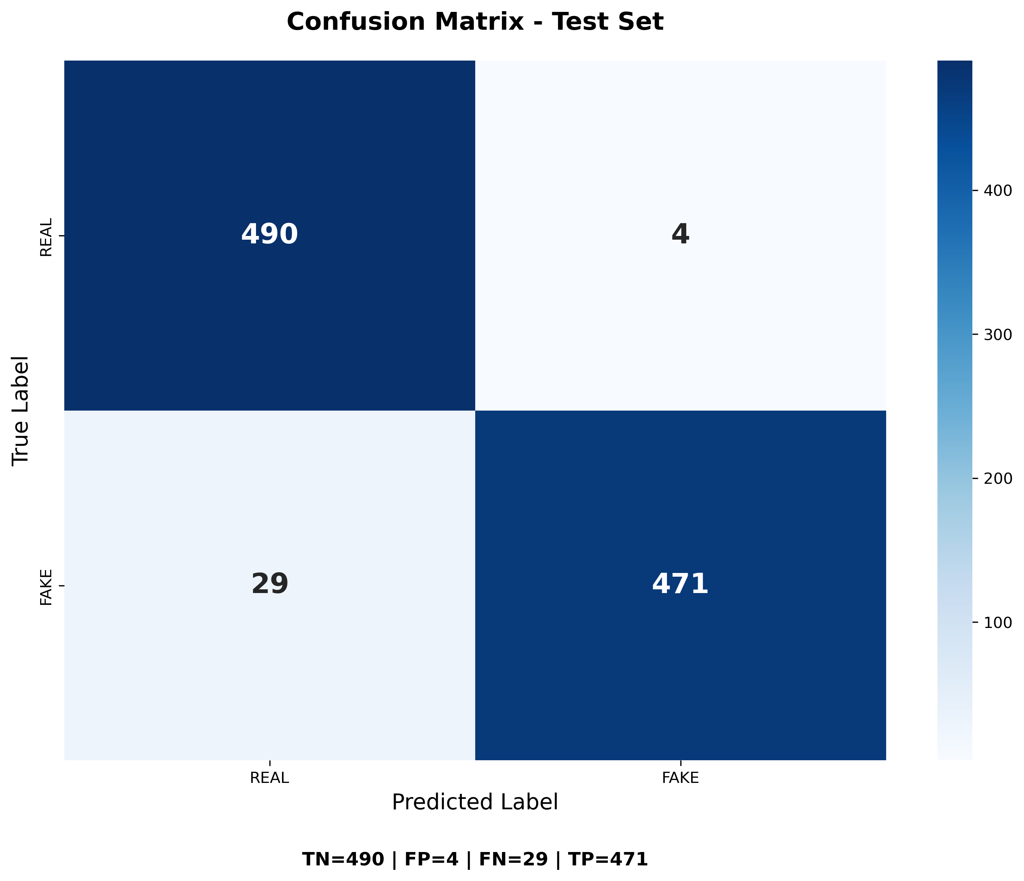
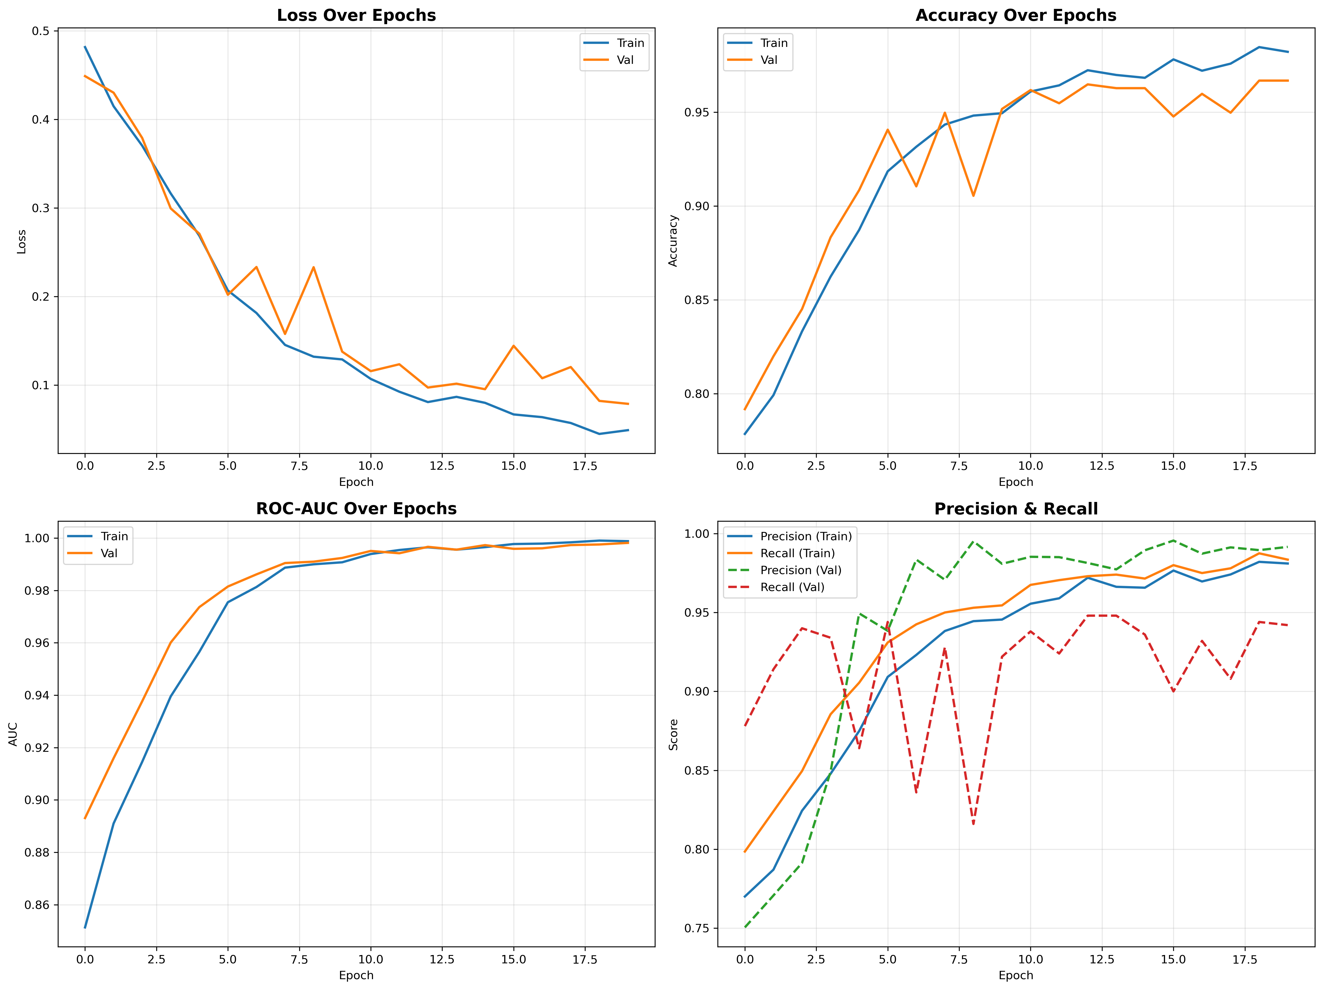

A Multi-Modal Deepfake detection system using Streamlit web interface was built. The breakdown of the system architecture.
1. Preprocessing Module (face detection and ROI), the ROI (Region of Interest) of the face is first found by the system and then it goes for analysis
2. MTCNN (Multi-task Cascaded Convolutional Networks) is used to detect the face, it detects the bounding box (x,y,w,h) and applies padding, this is to add context like the chin and hairline, which are common points in AI generated Deepfakes.
We also added an optional feature to erase the background, this was implemented using the GrabCut algorithm from OpenCV

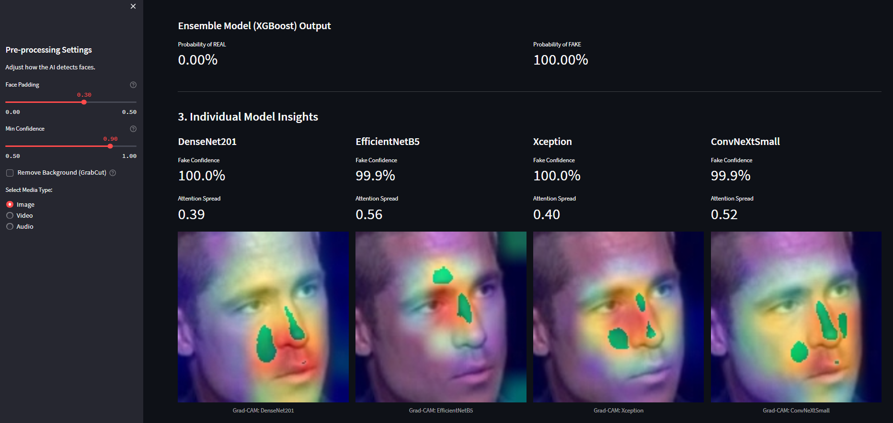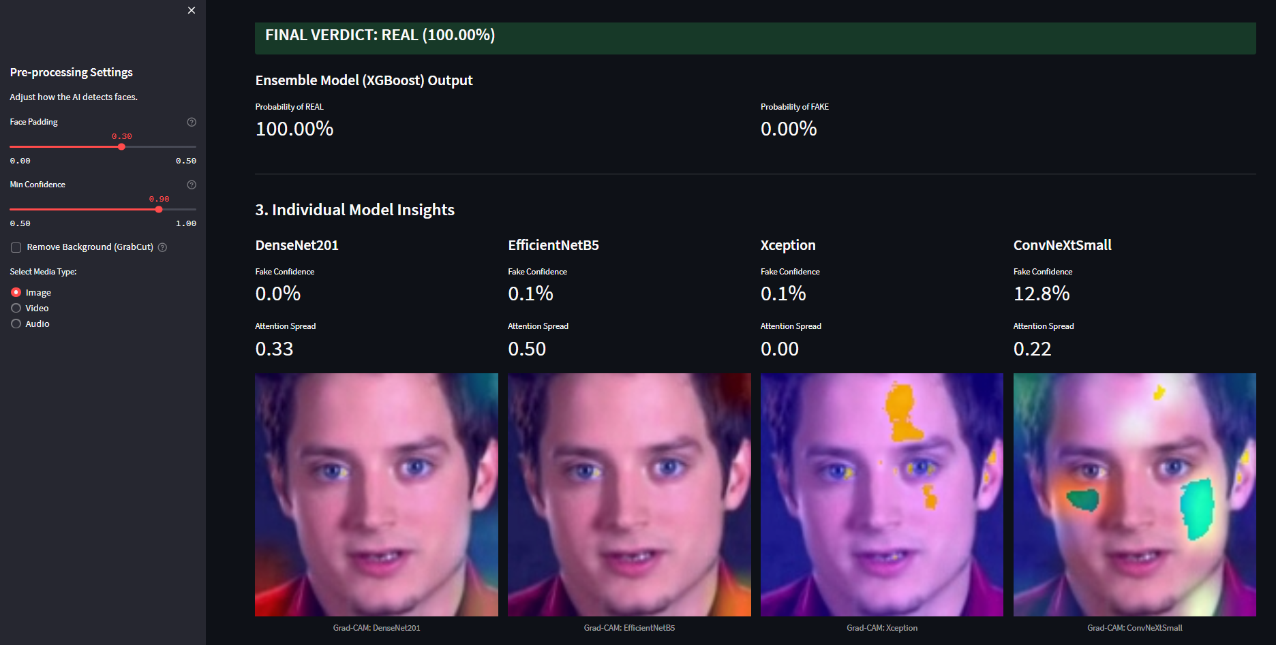
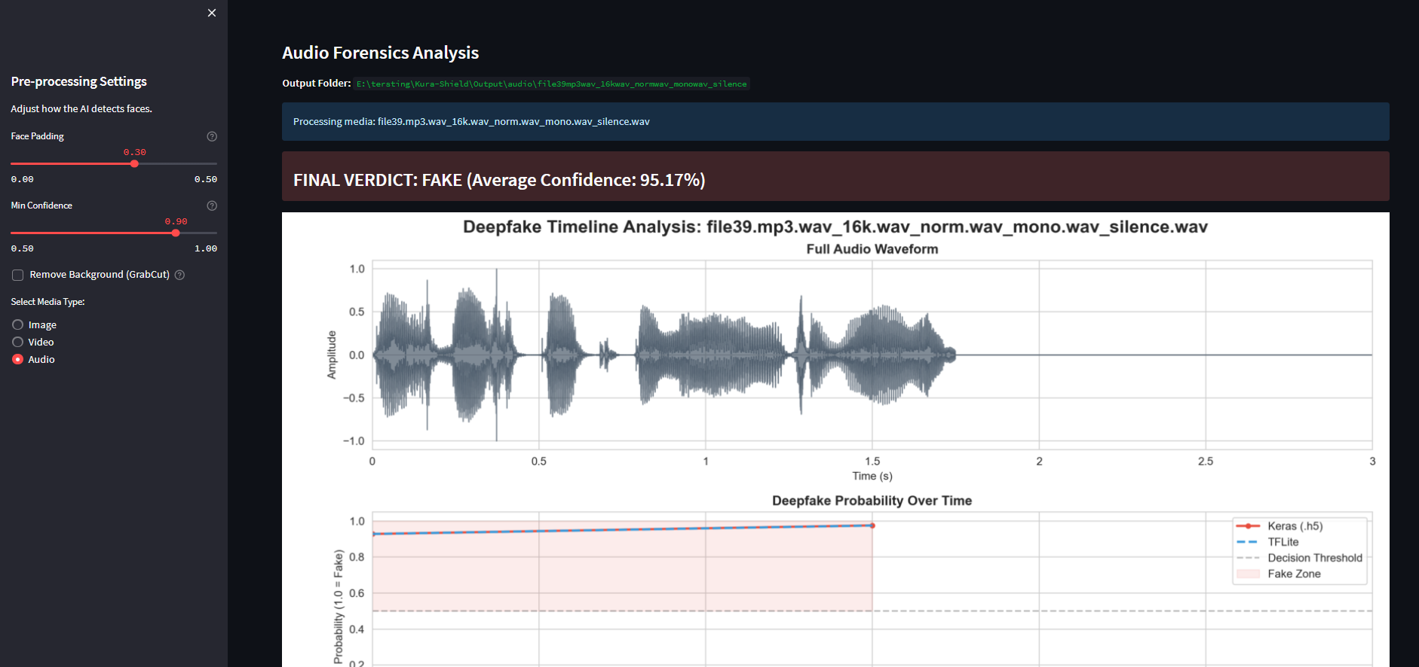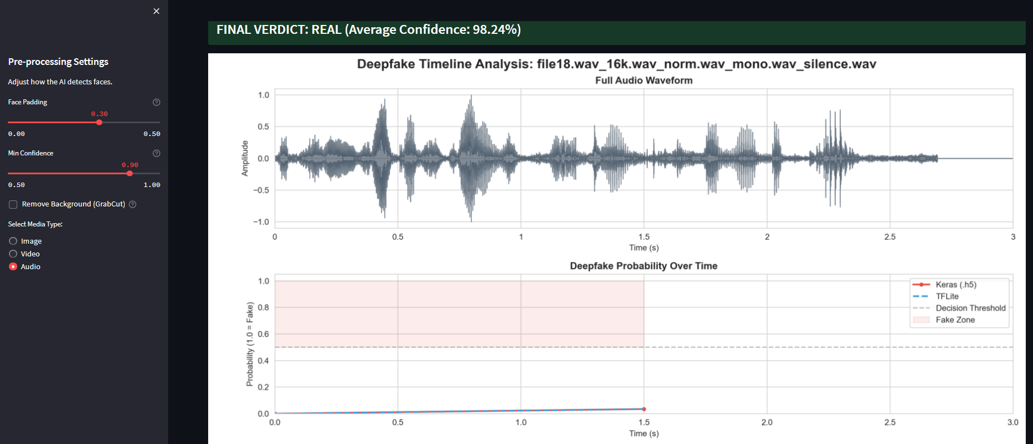

VI. Future Works
Deployment of these AI models on Social media, server side implementation of these CNN models will help reduce the spreading of fake AI generated content, when a user uploads an video/audio/image the server runs them throught the CNN models and if its fake its suspicious then it warns the user and watermarks the source, and if its fully confident that the content is fake then it flags the user.
Another implemention would be a web scrapping bto which will run on forums and websites that publish deepfake content and trace them using their username and other detailed avaliable, running a good backgorund check on the person uploding such content, and trying to gather as much information about them as possible, like a digital forencis/ OSINT search on the accounts that post such content and then generate a detailed report on them.
These are the future works we are working on to add to this proejct

VII. Conclusion
This research was successful in developing and deploying a multi-modal deepfake detection framework capable of indentifying manipulated faceial imagery from authentic content with good accuracy, by leveraging an ensemble learning the system overcomes the limitations of individual CNN architecture, offering a more generalized and resilent defence against AI generated Deepfakes.
The inclusion of feature selection algorithm like ReliefF and mRMR helps in optimizing the systems performance. The other remarkable inclusion was Explainable AI (XAI) via Grad-CAM, provides visual evidence of why a decision was made.
In conclusion, this research delivers a comprenhensive solution for deepfake forensic. By combining ensemble learning and the power of diverse CNN architectures with the decision-making capability of XGBoost and the transparency of Grad-CAM, the proposed system stands as a powerful front line tool against these AI generated audio/video/Image Deepfakes

References
[1] Y. Li, Y. Li, and Y. Wang, “A Multi-Modal and Multi-Scale Network for Deepfake Video Detection,” IEEE Transactions on Multimedia, vol. 25, pp. 7113-7126, 2023. doi: 10.1109/TMM.2022.3213032.
[2] R. Tolosana, R. Vera-Rodriguez, J. Fierrez, A. Morales, and J. Ortega-Garcia, “Deepfakes and beyond: A survey of face manipulation and fake detection,” Information Fusion, vol. 64, pp. 131-148, Dec. 2020. doi: 10.1016/j.inffus.2020.07.001.
[3] M. Jawad, A. M. Ali, and H. K. Al-khafaji, “A Lightweight CNN for Deepfake Detection,” IEEE Access, vol. 9, pp. 109593-109603, 2021. doi: 10.1109/ACCESS.2021.3101967.
[4] Y. Li, S. Wu, Y. Zhang, and X. Li, “Spatiotemporal-Aware Network for Deepfake Video Detection,” IEEE Transactions on Circuits and Systems for Video Technology, vol. 33, no. 9, pp. 5313-5326, Sept. 2023. doi: 10.1109/TCSVT.2023.3267592.
[5] P. Khorramshahi, A. Shahriyari, A. Ramachandra, and A. H. Feghahati, “FakeAVCeleb: A Novel Audio-Video Multimodal Deepfake Dataset,” IEEE Journal of Selected Topics in Signal Processing, vol. 17, no. 1, pp. 136-148, Jan. 2023. doi: 10.1109/JSTSP.2022.3227449.
[6] Manisha, V. S. Dhaka, and R. B. Battula, “Hybrid deepfake detection model using CNN and LSTM,” Multimedia Tools and Applications, vol. 83, pp. 22259–22272, Mar. 2024. doi: 10.1007/s11042-023-16781-6.
[7] A. K. Singh, P. Kumar, and R. Kumar, “Deepfake detection: a comprehensive review,” Artificial Intelligence Review, vol. 56, pp. 9635-9689, Sept. 2023. doi: 10.1007 /s10462-023-10408-y.
[8] Z. He, B. Zhang, W. Chen, and J. Wang, “A Robust Deepfake Video Detection Method Based on Fusion of Spatial and Temporal Features,” IEEE Access, vol. 9, pp. 127918-127930, 2021. doi: 10.1109/ACCESS.2021.3112270.
[9] Q. He, Z. Liu, H. Wang, and Z. Chen, "An Effective Vision Transformer with Cross-Attention for Deepfake Video Detection," IEEE Signal Processing Letters, vol. 30, pp. 76-80, 2023. doi: 10.1109/LSP.2023.3235651.
[10] S. Singh, J. S. Sidhu, R. Rani, N. K. Johal, G. Singh, and R. Singh, “A Survey of Deepfake and Its Detection Techniques,” IEEE Access, vol. 9, pp. 80728-80756, 2021. doi: 10.1109/ACCESS.2021.3085268.

